**Guideline: Adapt GSCons to component**

Following are the guidelines to adapt GSCons to any new component in mainstream (Camera/Radar)

**Important notes:**

Please note the following conventions:

xxx = component name in lowercase e.g hla, sr, em, fct etc

XXX = component name in upercase e.g HLA, SR, EM, FCT etc

**How do I start?**

Go to the path “04_Engineering\02_Development_Tools\scons_tools\setup” copy file **setup_mainstream.scfg** to the location “04_Engineering\03_Workspace\Component_Workspace”.

Modify **setup_mainstream.scfg**.

**What is the purpose of setup_mainstream.scfg?**

This file contains True/False flags. By default only sim_swc is True, which is common in all components. Make True to other simulation plugins, if available in the component.

**What is next?**

Go back to the path “04_Engineering\02_Development_Tools\scons_tools\setup” and execute **setup_mainstream.bat**.

**What is the purpose of setup_mainstream.bat?**

This batch file reads **setup_mainstream.scfg** which is just modified by you and setup_mainstream.py present in the same directory. It takes the information and creates folders/subfolders (if not present already) and copies all the GSCons configuration files i,e .scfg’s.

**What happens after I run setup_mainstream.bat?**

Folders and subfolders are created as shown below and GSCons configuration files will be copied

1. 04_Engineering\03_Workspace\Component_Workspace\xxx
2. 04_Engineering\03_Workspace\Component_Workspace\xxx_sim\sim_swc_xxx
3. 04_Engineering\03_Workspace\Component_Workspace\xxx_sim\sim_swc_xxx_vis
4. 04_Engineering\03_Workspace\Component_Workspace\xxx_sim\sim_swc_xxx_adapt

**What is next?**

Modify all the GSCons configuration files (“.scfg’s”) as explained inside in the top of the file.

First modify **sconstruct_config.scfg** then **sconscript_setup_config.scfg** and then the rest. It is compulsory to modify all the “.scfg’s” present.

**What is the purpose of sconstruct_config.scfg?**

It contain information’s of cores used in the component. By default all are False, make change as per component. It also defines list of source folders for simulation targets to be built, they are explained in the comments inside the file. If component has one algo (which is by default) and have utilities then define the path in line 107 and comment out the lines 110-115

**What is the purpose of sconscript_setup_config.scfg?**

This file contains the information of copy operations of SConscript.py (GSCons python scripts) from source to destinations. For eg:

name: name of the feature, only for documentation, not read by GSCons.

copy: Flag to copy the files given under source and dest_folder.

By default all the necessary copy operations are made to True. If necessary, change the flag to True/False.

**What is the purpose of algo_config.scfg?**

This file reads algo_lib_file_list.scfg. This file contains the information for generating SDL files. It also contains information of polyspace (which is not required for mainstream). Read the comments provided in the top of the file.

**What is the purpose of algo_lib_file_list.scfg?**

This file contain source lists providing paths of the source code, headers, includes etc to be used for the build. In mainstream, due to multiple-project-build supportbeen provided every component has to provide project specific files in the source list as shown below

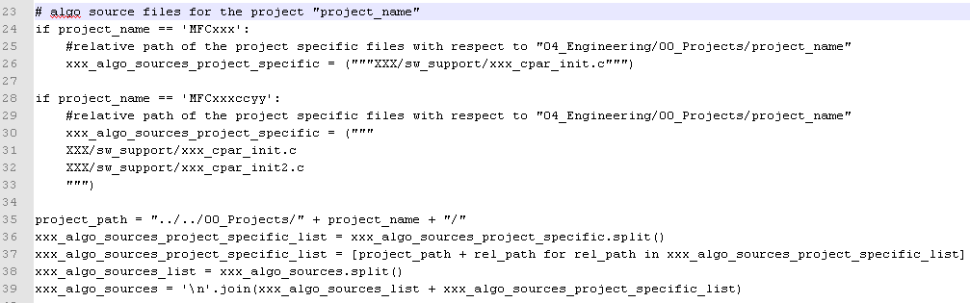

**Note1:** There should be one ‘if’ statement per application project as seen in Line 23 and 28. All project specific file paths should be updated as seen in Line 26 and 30-33.   
Line 35-39 are fixed and won’t be changed once introduced.  
  
**Note2:** The adaptation in the picture above have to be done per source list per *_list.scfg. E.g. there are 4 source lists in algo_lib_file_lists.scfg template, hence adaptations to be done 4 times. Please refer to (Line 23-39, Line 57-70, Line 79-89, Line 97-109)  
  
**Note3:** In case your component doesn’t have any project specific source code, and you are setting up the component for the first time using template above, please remove the lines shown above from *_list.scfg file.

For further information, find the doc in the link <http://ims-adas:7001/si/viewrevision?projectName=/ADAS/SW/Integration/03%5fDocuments/Sensorics/project.pj&selection=Mainstream%5fproject%5fspecific%5fSil%5fbuild.docx>

**What is the purpose of simenv_config.scfg?**

This file contains information of compiler flags, linker flags, defines, link libs, link libs paths etc. Read the comments inside the file for more information of each variable used.

**What is the purpose of sim_swc_config.scfg?**

This file reads **sim_swc_xxx_file_list.scfg**. This file contains information of external libs used and their respective paths. This file also contains information of pc simulation SDL file.

**What is the purpose of sim_swc_xxx_file_list.scfg?**

The purpose of this file is similar to **algo_lib_file_lists.scfg** defined above which contain source lists providing paths of the source code, headers, includes etc to be used for the PC simulation build. This file also contains project specific file lists as shown below

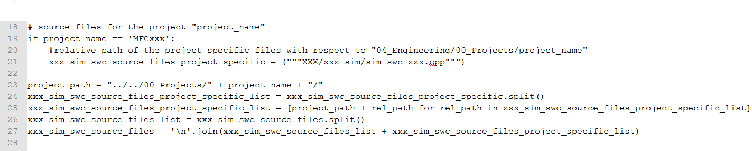

If component doesn’t have project specific files please remove this part of code from the file.

**The last step**

Open command prompt in the location“04_Engineering\03_Workspace\Component_Workspace\xxx” and execute **scons no_target**. At the end, if it says **Build Succeeded** then your GSCons set up is ready.